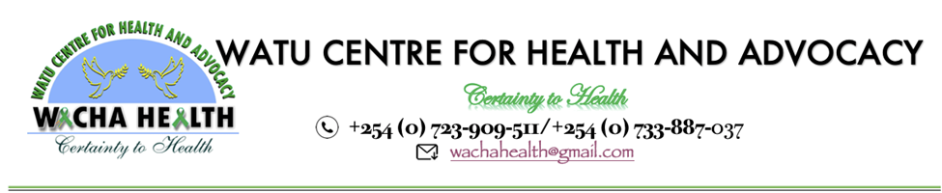

Watu Center for Health and Advocacy (WACHA CBO) is seeking a qualified and experienced consultant or consulting firm to develop our organizational strategic plan for the period 2024-2027. We are a dynamic organization dedicated to providing comprehensive health and mental health services, with a focus on comprehensive Sexual Reproductive Health and Rights (SRHR), including HIV prevention, sexual reproductive health, and advocacy for Young Key and vulnerable people in the community in Kwale and Mombasa counties on the Kenya Coast.
Objective of the Consultancy: Th e primary objective of this consultancy is to collaboratively develop a robust and forward-thinking strategic plan that aligns with our mission and vision. The plan will guide our activities in the next three years, focusing on areas such as mental health, sexual reproductive health, HIV prevention, TB testing, human rights advocacy, and service provision for Key Populations (KP), including YGBMSM using drugs.
Key Responsibilities: The selected consultant/firm will be responsible for, but not limited to, the following tasks:
- Stakeholder Engagement:
  - Facilitate consultations with key stakeholders, including staff, partners, and community representatives, to gather input and insights.
- Situation Analysis:
  - Conduct a thorough situation analysis, considering current health and mental health trends, community needs, and organizational capacities.
- Strategic Planning Workshops:
  - Facilitate strategic planning workshops with the organization's leadership and key staff to identify goals, objectives, and action plans for the next three years.
- Capacity Building Programs Design:
  - Develop LGBTIQ and KP accredited capacity-building programs on mental health, SRH, HIV, TB, and human rights advocacy.
- Service Delivery Framework:
  - Work with the organization to outline a service delivery framework that ensures high and consistent quality service standards for Key Populations and People living positively.
- Drafting the Strategic Plan:
  - Based on the outcomes of the workshops and consultations, develop a comprehensive and actionable strategic plan document for the organization.
- Feedback and Revisions:
  - Incorporate feedback from the organization's leadership and key stakeholders to refine and finalize the strategic plan.
Qualifications and Requirements:
- Demonstrated experience in developing strategic plans for organizations in the health and advocacy sectors, with a focus on LGBTQIA+ and Key Populations.
- Knowledge of the local context and issues related to mental health, sexual reproductive health, HIV, TB, and human rights advocacy in Kwale and Mombasa counties.
- Strong facilitation skills for engaging diverse stakeholders in the planning process.
- Familiarity with accreditation processes for capacity-building programs.
Submission Guidelines: Interested consultants/firms are invited to submit their proposals, including a detailed methodology, timeline, and budget, by [Insert Deadline]. Proposals should be sent to the Executive Director at executivedirector@wachahealth.org.
Timeline:
- Proposal Submission Deadline: 13th January 2024
- Consultant Selection: 15th January 2024
- Project Kick-off: 18th January 2024
- Final Strategic Plan Submission: 15th February 2024
We look forward to receiving comprehensive proposals from qualified consultants or consulting firms who share our commitment to creating a center of excellence in Sexual Reproductive Health and Rights (SRHR) including mental well-being for Young Key and vulnerable people in the community on the Kenya Coast region.

